**Deep Learning Mobile Application to analyze Smoking Patterns**

# Introduction

The main deliverables for the project is to detect when the subject is smoking and further analyze his/her smoking behavior which will act as the training dataset to predict the subject’s future actions.

The current state of the project:

Testing:

For testing the dataset a computer vision model is developed to detect/mimic the cigarette holding position. The model detects and captures the subject’s photo if the posture is detected.

This model is solely done to train the dataset on which the model will be trained in the future. The final model is will not have any computer vision based model instead will be based on the combination of the following sensors :

* IMU
* HTM ( Hand to Mouth) sensor
* RTC DS3231 (I2C Real time Clock)
* Heart Rate Sensor
* SpO2

# The Analysis

We aim to try out various deep learning algorithms to implement on the above mentioned scenario and see which yields the best results. As of now we have started to work on the following models :

* PyTorch
* Caffe

We aim to deliver a detailed analysis of the smoking pattern and predict the subjects next cycle

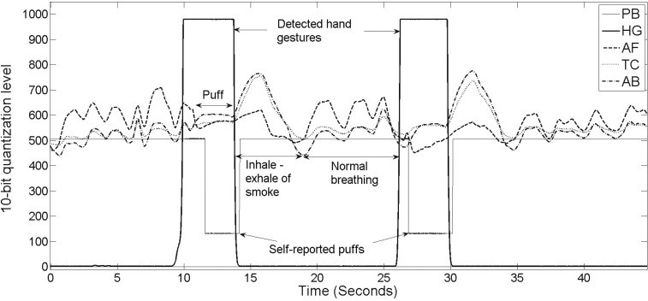

Push button (PB) hand-to-mouth gesture sensor (HG) oral and nasal airflow (AF) thoracic (TC) abdominal respiratory band (AB)

**Smoking Posture Detection Model**



# The App

A cross platform app is being built as a companion to the deep learning app with the smart watch.

These are the current designs of the app:

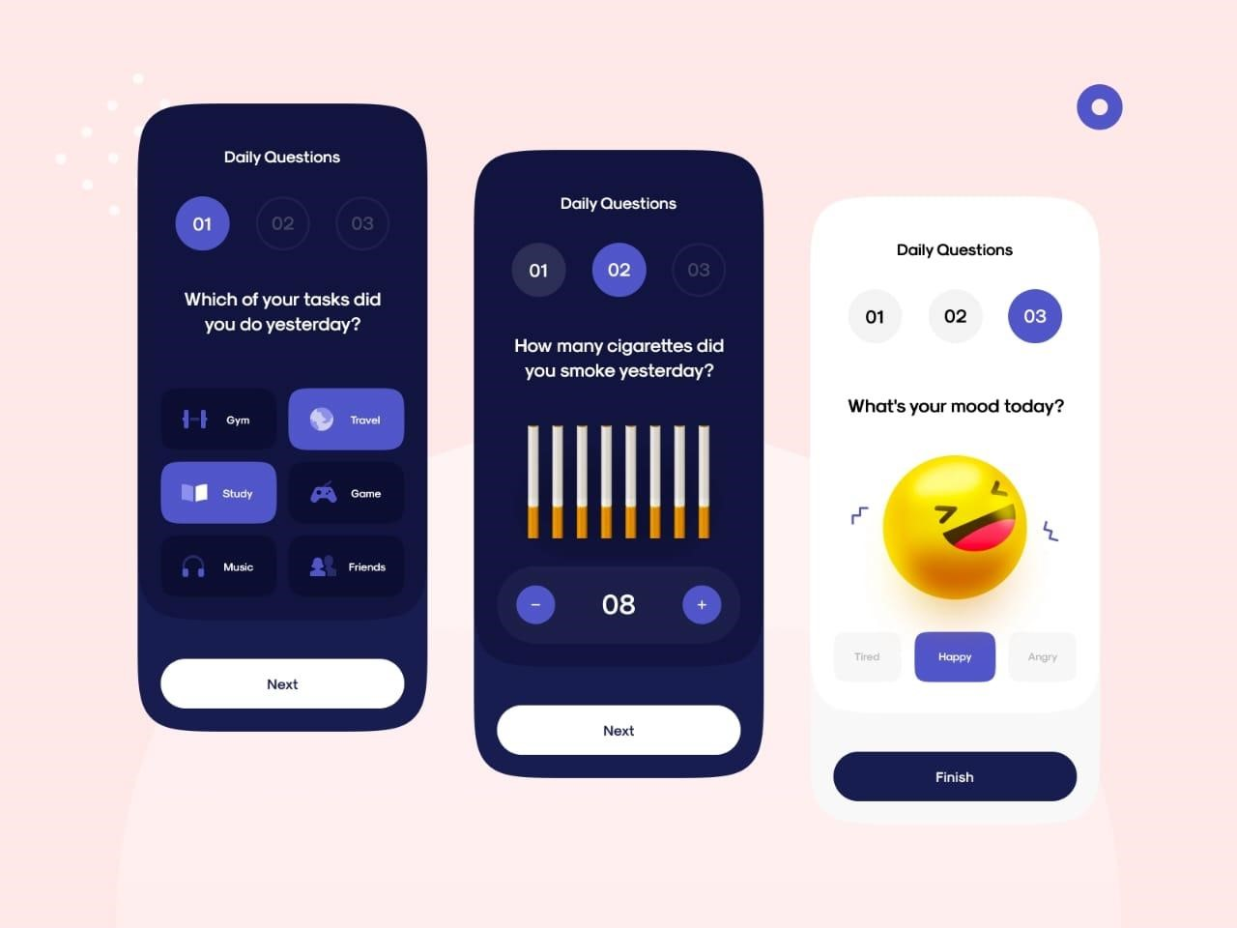

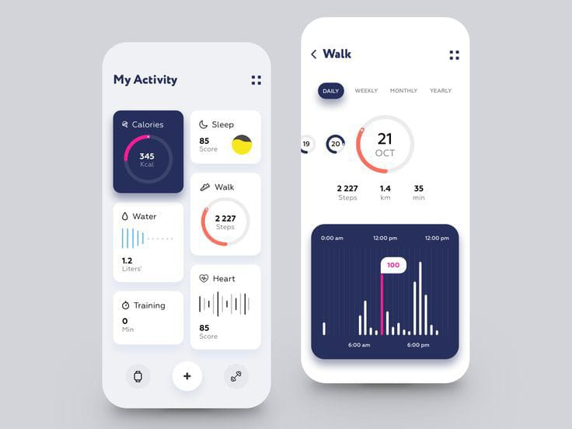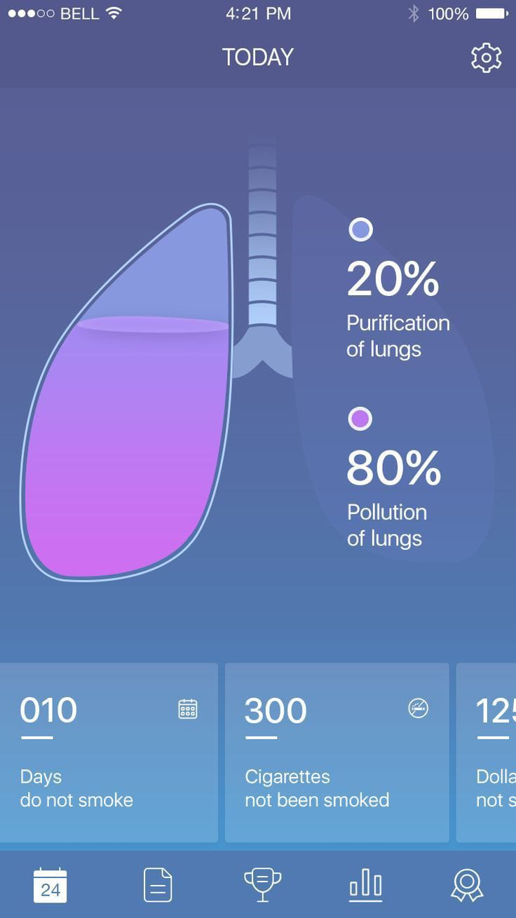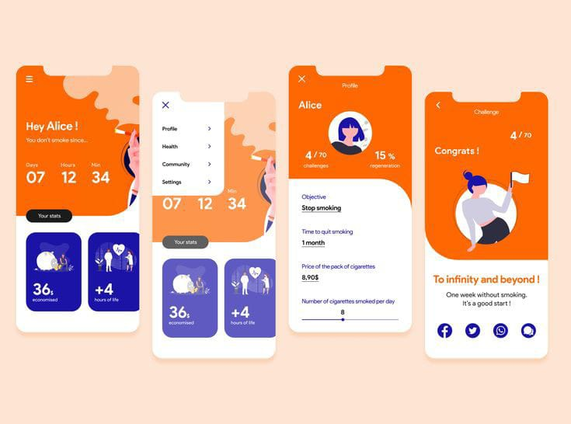

We want the app to be intuitive and fun to use and act as a mood booster for the users instead of being a conventional & antidepressant app.